**ASSIGNMENT - 1**

1. Display the contents of EMP, DEPT tables

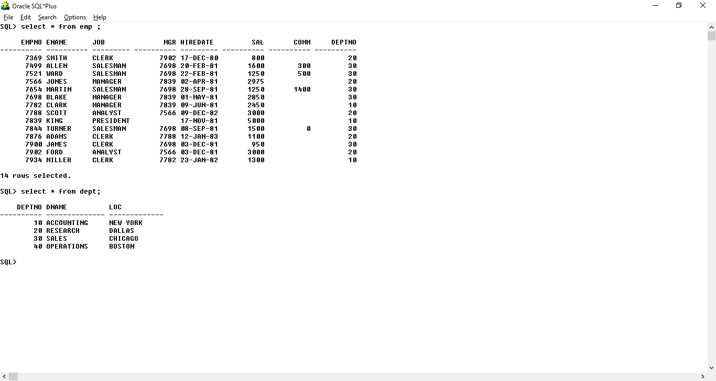

2. Display employee name, job title and salary of all employees.

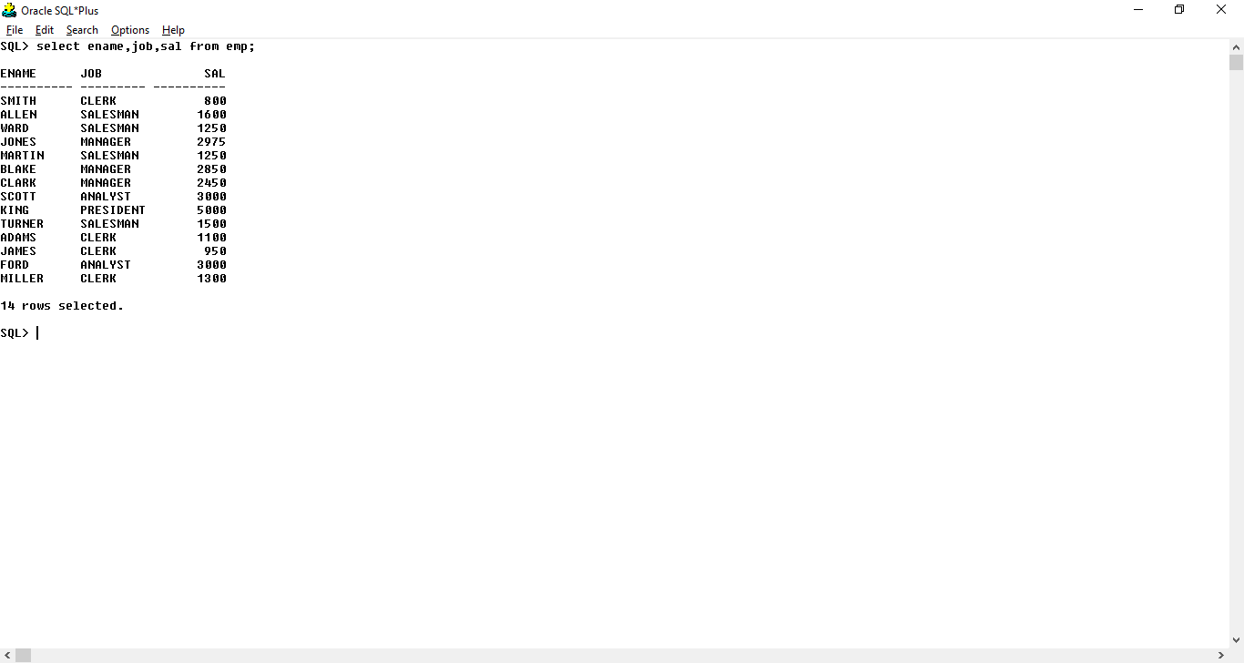

3. Display details of all employees working in department 10.

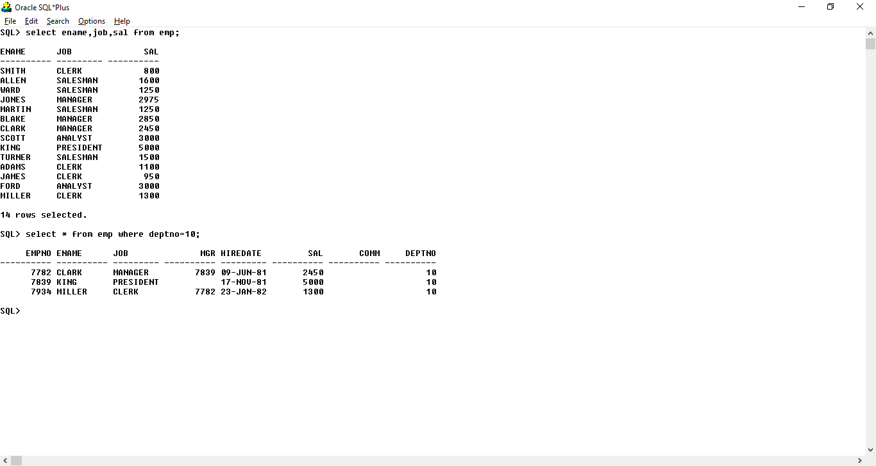

4. Display details of all employees working as MANAGER.

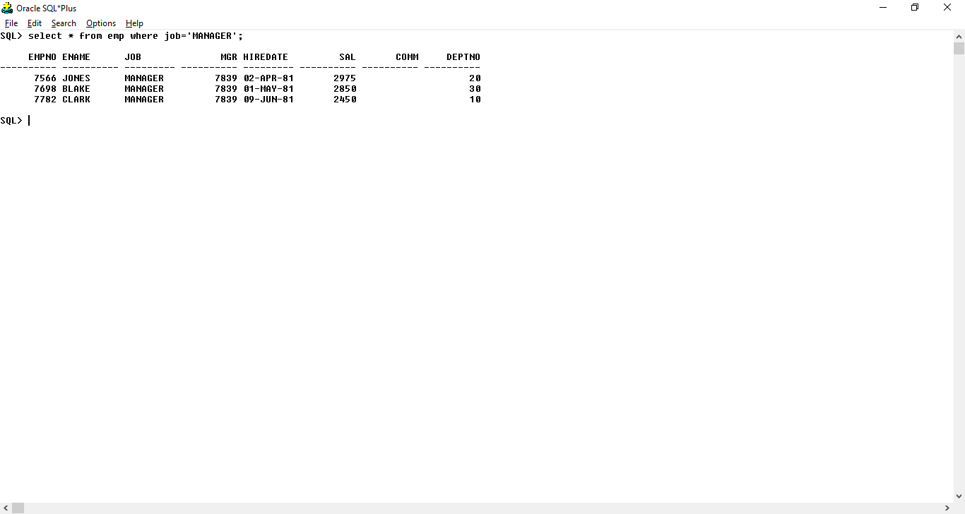

5. Display all jobs in the organization.

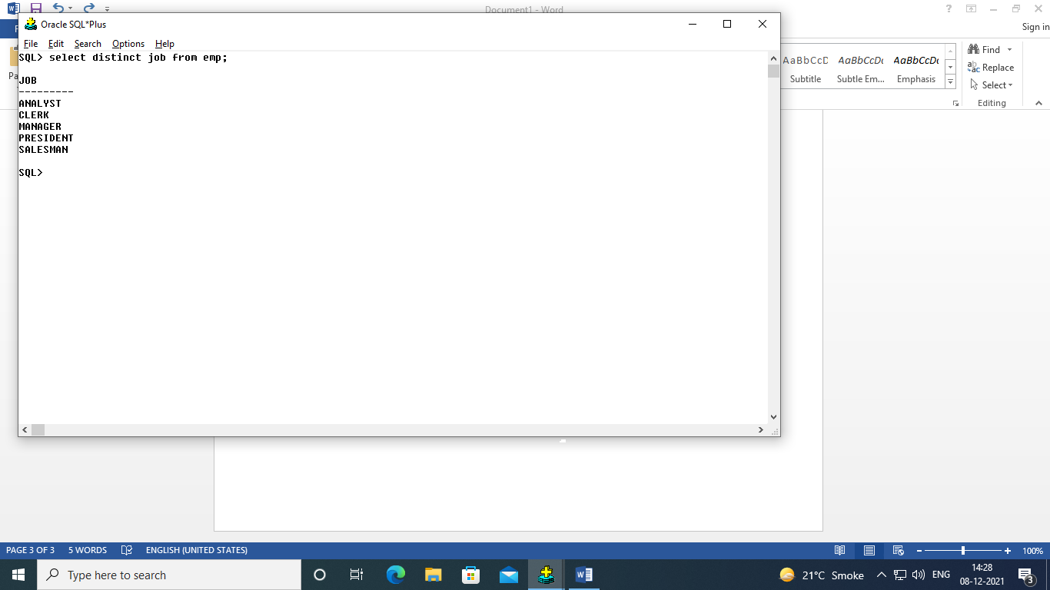

6. Display numbers of all departments where employees are working.

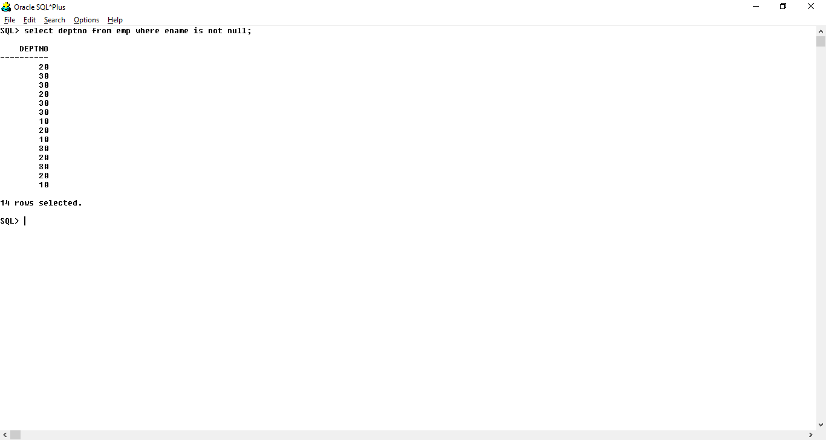

7. Display details of all employees with their annual salaries.

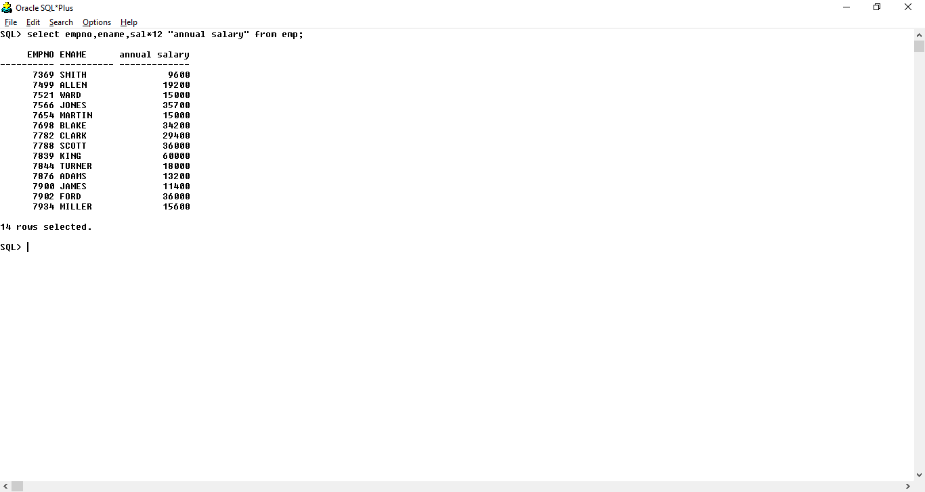

8. Display details of all employees who are not working in department 10 & 30.

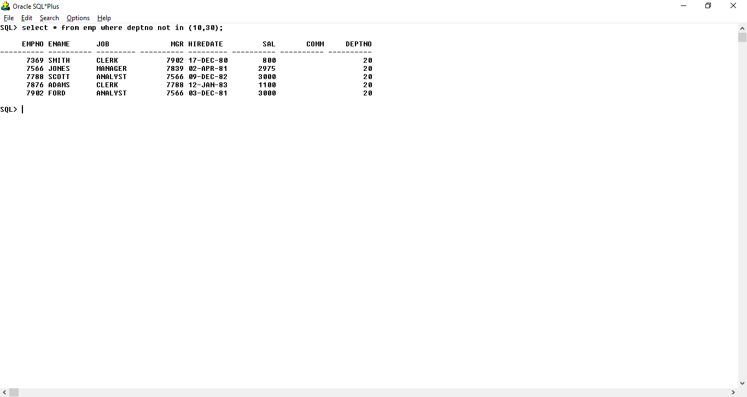

9. Display the names and job titles of all employees whose salary is either 1000 or 3000 or 5000.

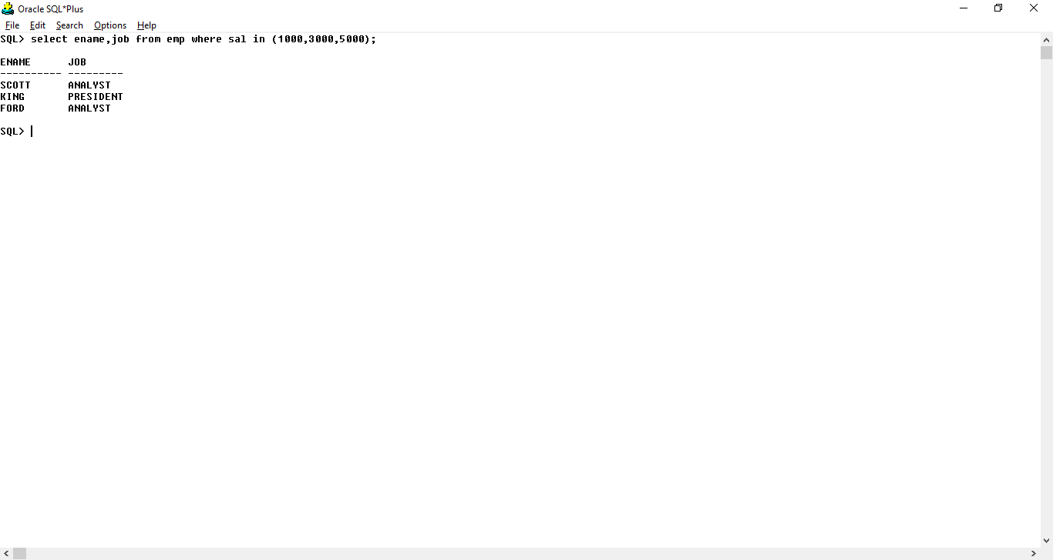

10. Display employee number, salary and jobs of all employees of department number 20.

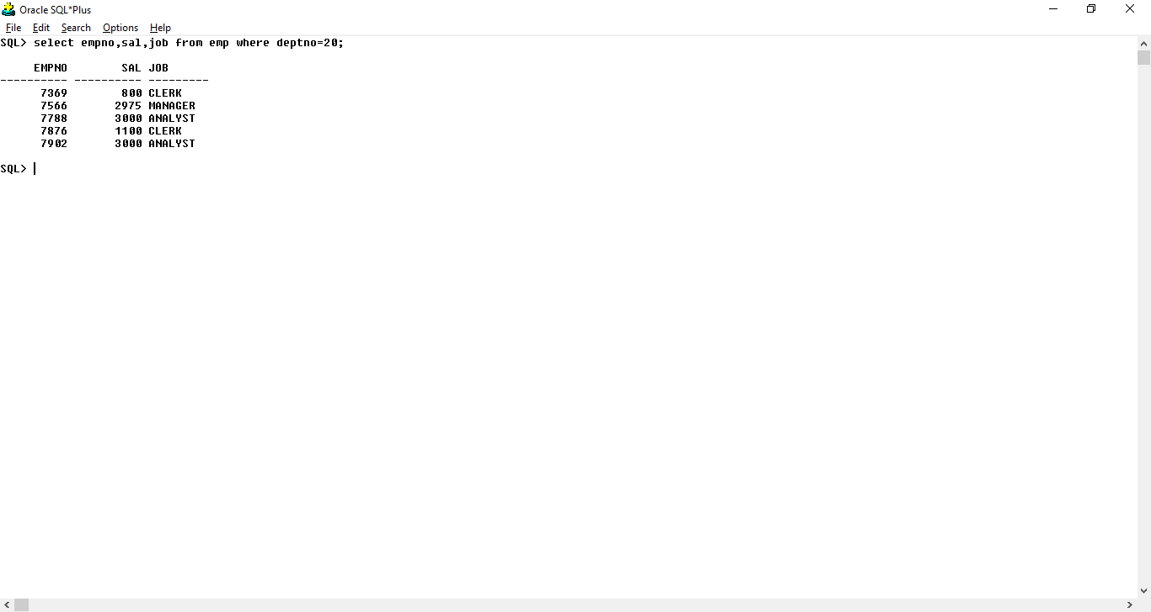

11. Display employee number and name of those employees who do not earn commission.

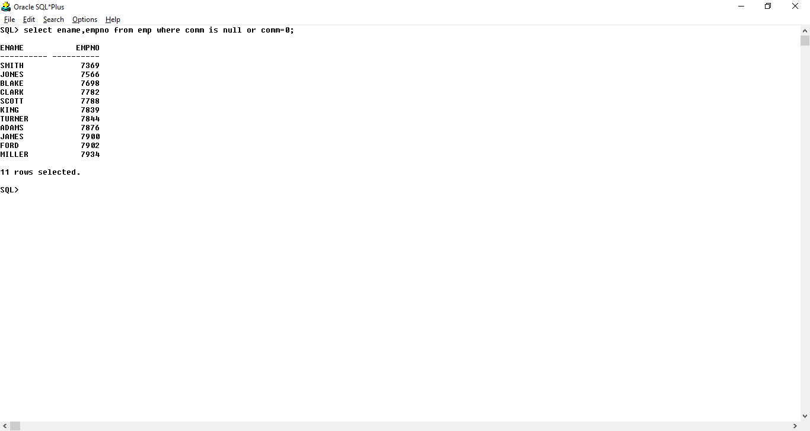

12. Display details of all employees who were hired before 1st Jan 1989

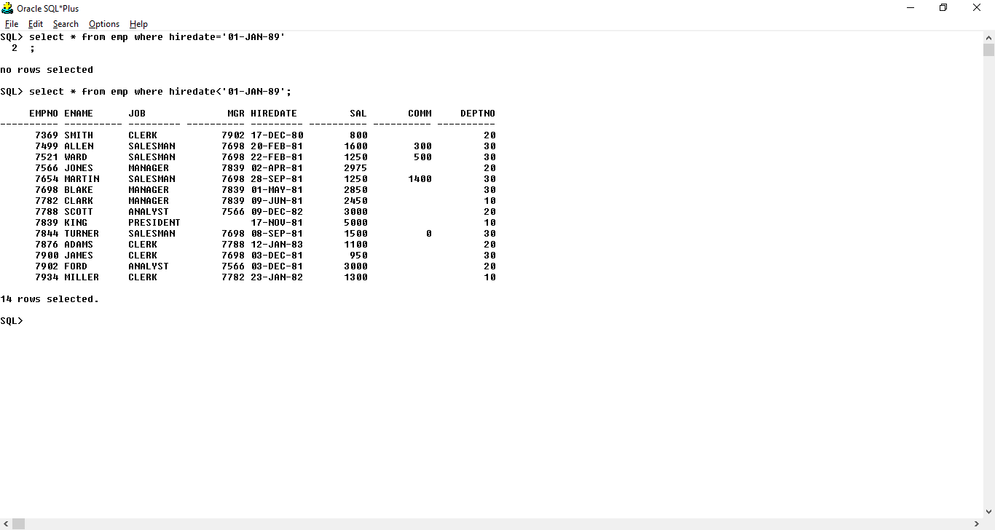

**ASSIGNMENT - 2**

1. Display total number of employees working in organization.

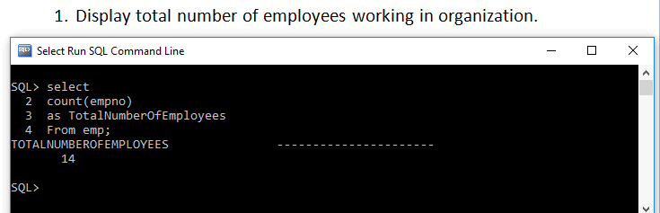

2. Display employee number, name of those employees, who do not earn commission and they are not clerks.

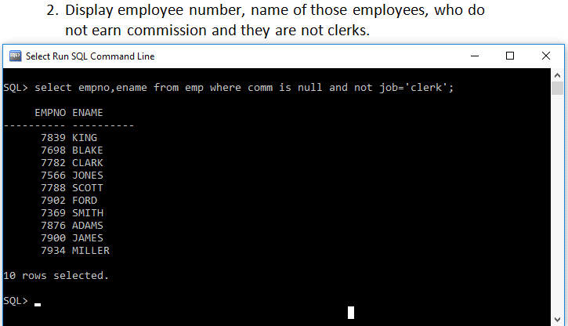

3. Display details of all employees who were hired in year 1981.

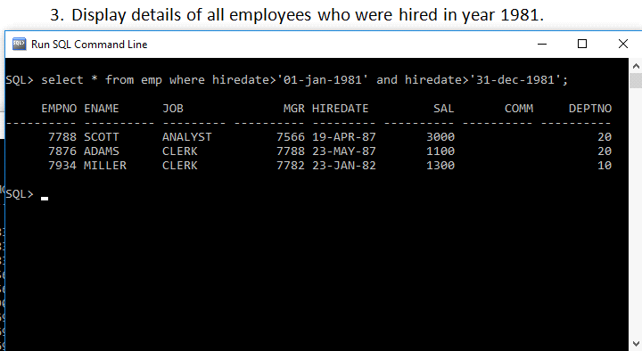

4. Display employee number, salary and department number of all employees, department wise.

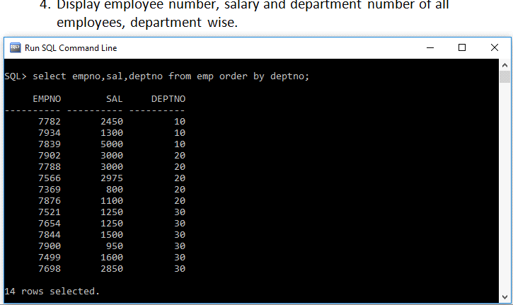

5. Display minimum and maximum salaries in organization.

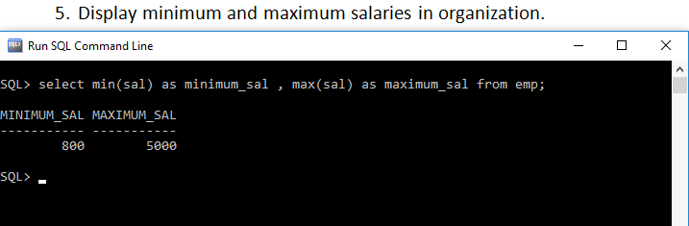

6. Display maximum salary department wise.

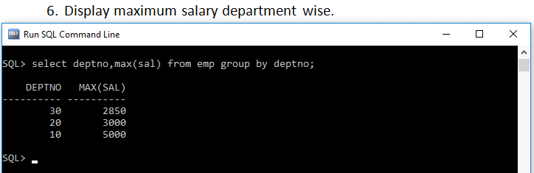

7. Total number of employees who are not entitled for commissions.

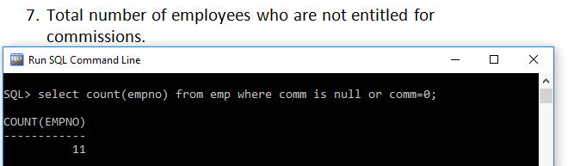

8. Calculate job wise average salary.

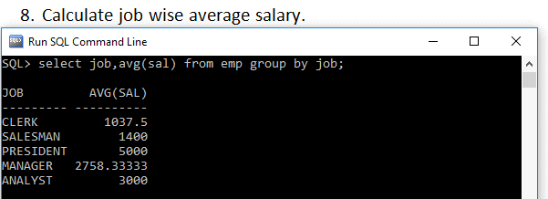

9. Display names, employee number of all employees whose name starts with letter ‘J’ and ends with ‘S; and were hired before ‘1-January-1982’.

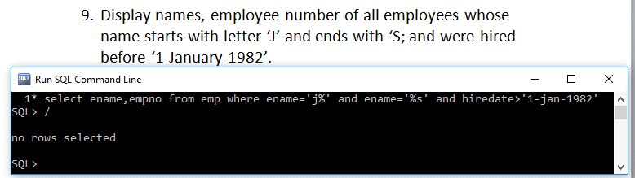

10. Display employee number and department number of all employees who are earning more than 2500 and whose name has third letter as ‘R’ and working in department 10.

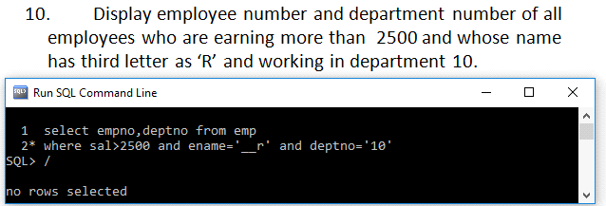

**ASSIGNMENT – 3**

1. Create a query to display all the data from the EMP table. Separate each column by a comma. Name the column THE_OUTPUT.

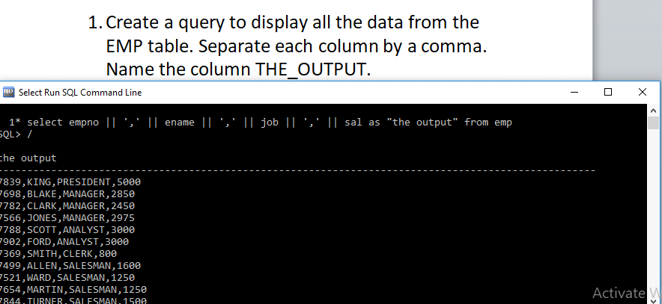

2. Display the name concatenated with the job, separated by a comma and space, and name the column ‘Employee and Title.’

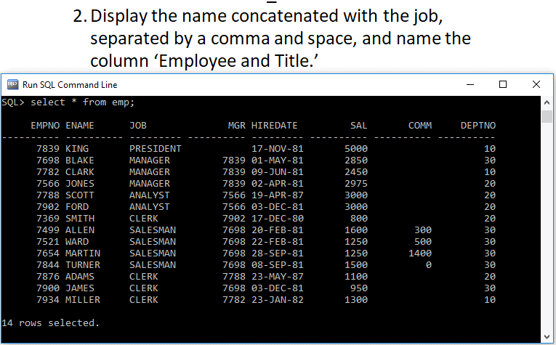

3. Display the employee if an employee is a president or a sales representative, and if the employee earns more than $15,000.

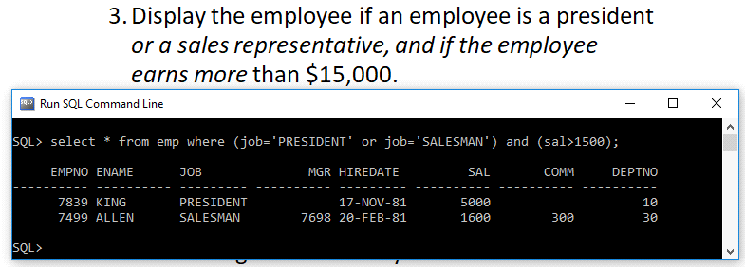

4. Display the last names and salaries of all employees. Order the result by department number, and then in descending order by salary.

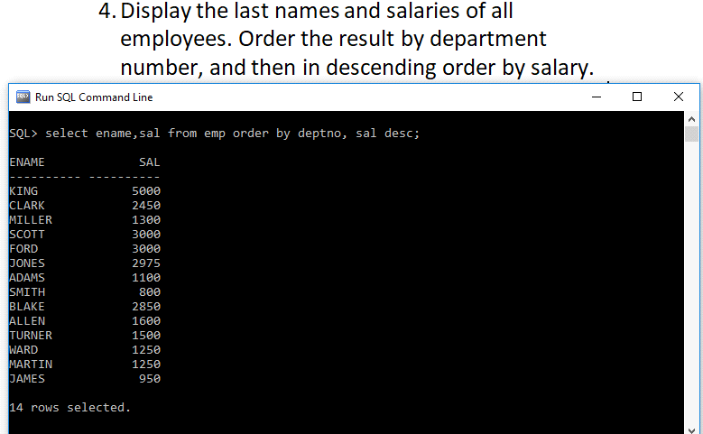

5. Display the last name, salary, and commission for all employees who earn commissions. Sort data in descending order of salary and commissions.

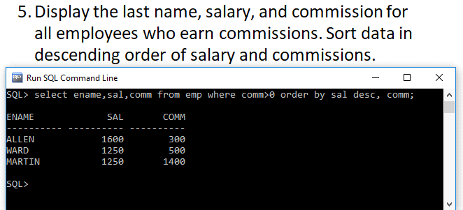

6. Display the name of all employees who have a and an e in their name.

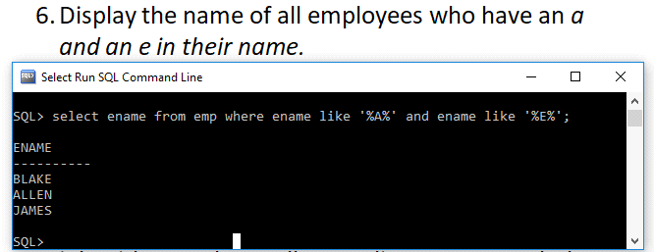

7. Display the name, job, and salary for all employees whose job is sales representative or clerk and whose salary is not equal to 2500, 3500, or 7000.

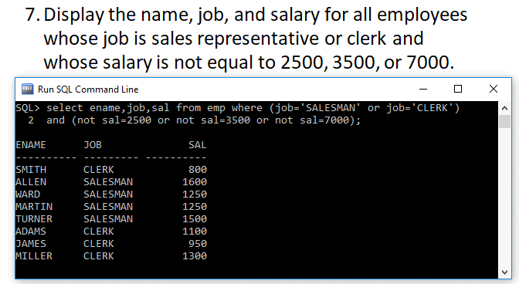

8. Display of average salaries of those departments that have an average salary greater than 8,000.

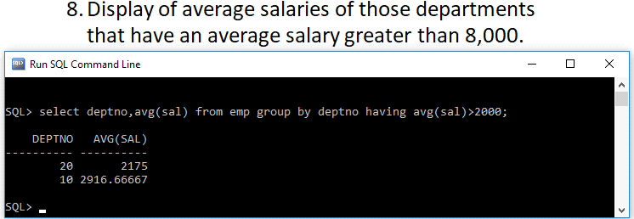

9. Display the job and total monthly salary for each job with a total payroll exceeding 13000. Exclude sales representatives and sorts the list by the total monthly salary.

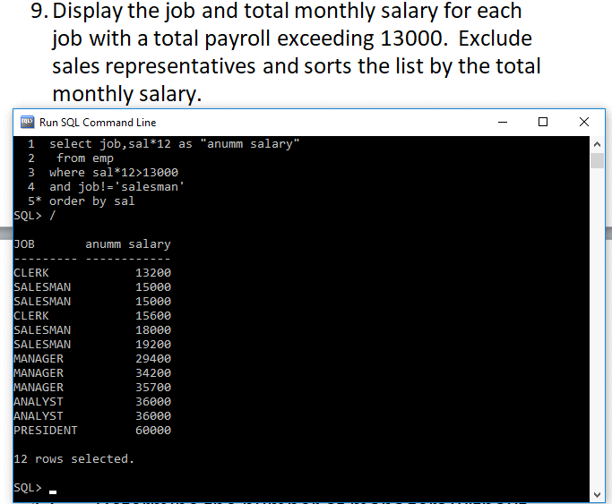

10. Displays the maximum average salary of departments.

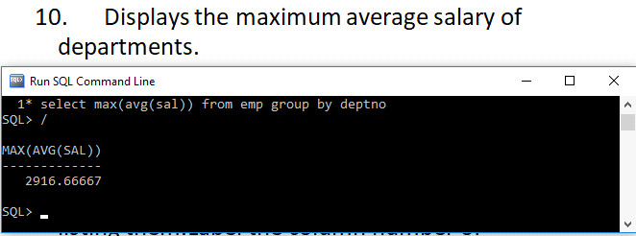

11. Display the highest, lowest, sum, and average salary of all employees. Label the columns Maximum, Minimum, Sum, and Average, respectively.

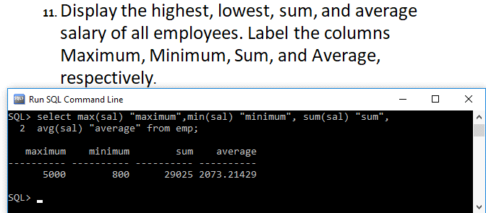

12. Determine the number of managers without listing them. Label the column number of Managers.

